 | Monday | Tuesday  WEEK 1 MENU | Wednesday | Thursday | Friday
Mains | Chicken Curry &  Wholegrain Rice  Chicken Fillet & Stuffing | Spaghetti Bolognese  Sweet Chilli Chicken  Chicken with Noodles | Chicken Curry & Boiled Rice  Naan Bread  Baked Salmon with Lemon Crust | Irish Stew  Sweet & Sour Pork & Rice  Oven Baked Sausages | Lasagne  Fish & Veg Pie with potato topping
Vegetarian | Vegetable Curry & Rice | Stir Fry Veg & Noodles | Vegetable Crumble | Sweet & Sour Vegetable & Rice | Vegetable & Pasta Bake
Snacks | Filled Baked Potato  Chicken Fillet Burger | Sweet Chilli Chicken Wrap  Hoagie | Hot & Spicy Chicken Baguette  Chips & Curry Sauce | Hot Dog  Cheese & Tomato Pizza | Filled Panini  Steak Burger in Floury bap
Veg  Potato  Gravy | Diced Carrots & Parsnips  Chips  Baked Potato  Mashed Potato  Baked Beans | Peas & Sweetcorn  Turnip  Baked Potato  Mashed Potato | Chips  Baby Potatoes  Baked Potato  Mixed Vegetable | Cabbage  Baton Carrots  Baked Potato  Boiled Potatoes | Cauliflower & Broccoli  Garden Peas  Mashed Potato
Salad | Pasta Salad  Side Salad | Coleslaw  Side Salad | Side Salad  Potato Salad | Pasta Salad  Side Salad | Side Salad  Coleslaw
Desserts | Fruit Sponge  Custard  Fresh Fruit Salad | Swiss Roll  Custard  Fresh Fruit Salad | Carrot Cake  Custard  Fresh Fruit Salad | Fruit Pavlova  Custard  Fresh Fruit Salad | Flakemeal Biscuit  Custard  Fresh Fruit Salad
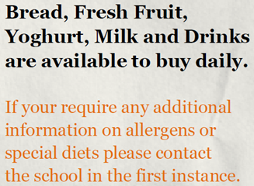
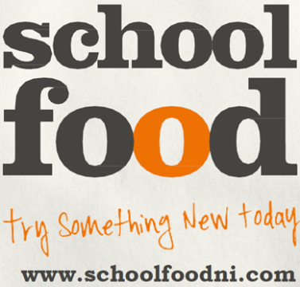

WEDNESDAY IS RED MEAT FREE DAY

