 | Monday | Tuesday | Wednesday | Thursday | Friday
Soup | Vegetable/Chicken Soup  Crusty Roll | Vegetable/Chicken Soup  Crusty Roll | Vegetable/Chicken Soup  Crusty Roll | Vegetable/Chicken Soup  Crusty Roll | Vegetable/Chicken Soup  Crusty Roll
Mains | Irish Stew  Tuna Pasta Bake | Chicken Curry & Rice  Naan Bread  Roast Chicken & Stuffing | Beef Stroganoff & Rice  Chicken & Broccoli Pasta Bake | Chicken Curry & Wholegrain Rice  Naan Bread  Lasagne | Poached Fish in Parsley Sauce  Chicken & Vegetable Pie with Potato Topping
Vegetarian | Chinese Style Fried Rice | Vegetable Curry | Vegetable Pasta Bake | Macaroni Cheese | Cheese & Broccoli Bake
Snacks | Meatball Panini  Sweet Chilli Chicken Wrap | Filled Baked Potato  Chips & Curry Sauce | Steak Burger in Floury Bap  Filled Panini | Cheese & Tomato Pizza  Chicken Fillet Burger | Hot Dog  Filled Baked Potato
Veg  Potato  Gravy | Diced Carrots  Cabbage  Creamed/Baked Potato | Diced Turnip  Broccoli  Creamed Potatoes  Chips | Broccoli  Mixed Vegetable  Mashed Potato  Baked Potato | Peas & Sweetcorn  Baton Carrots  Chips  Baked Potato | Cauliflower  Peas  Baked Beans  Parsley Potato  Baked Potatoes
Salad | Side Salad  Pasta Salad | Potato Salad  Side Salad | Side Salad  Coleslaw | Pasta Salad  Rice Salad | Side Salad  Pasta Salad
Desserts | Fruit Muffin  Flakemeal Biscuit  Fresh Fruit Salad  Custard | Fruit Sponge  Fresh Fruit Salad  Custard | Carrot Cake  Fresh Fruit Salad  Custard | Fruit Jelly  Fresh Fruit Salad  Custard | Jam Swiss Roll  Fresh Fruit Salad  Custard
WEEK 2 MENU
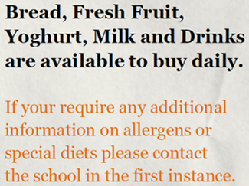
TUESDAY IS RED MEAT FREE DAY

