 | Monday | Tuesday | Wednesday | Thursday | Friday
Soup | Vegetable/Chicken Soup  Crusty Roll | Vegetable/Chicken Soup  Crusty Roll | Vegetable/Chicken Soup  Crusty Roll | Vegetable/Chicken Soup  Crusty Roll | Vegetable/Chicken Soup  Crusty Roll
Mains | Chicken Curry & Rice  Chicken Tomato & Basil Pasta | Baked Gammon  Chicken & Vegetable Pasta | Lasagne  Tuna & Pasta Bake | Sheperd’s Pie  Sweet Chilli Chicken Tagliatelle | Baked Fillet of Plaice  Oven Baked Sausages
Vegetarian | Vegetarian Curry & Rice | Macaroni Cheese | Vegetable Crumble | Filled Baked Potato | Cauliflower & Broccoli Bake
Snacks | Filled Panini  Chicken Fillet Burger | Spicy Meatball Panini  Pepperoni Pizza | Steak Burger in Floury Bap  Spicy Chicken Wrap | Pepperoni Pizza  Filled Baked Potato | Hot Dog  Filled Panini
Veg  Potato  Gravy | Peas & Sweetcorn  Baked Beans  Mashed Potatoes  Chips | Cabbage  Mixed Vegetables  Creamed Potato  Baby Boiled Potato | Garden Peas  Diced Turnip  Mashed Potato  Steamed Potato | Diced Carrots  Carrot & Parsnip  Baked Potato  Baby Boiled Potato | Cauliflower  Broccoli  Baked Beans  Parsley Potatoes  Chips
Salad | Rice Salad  Side Salad | Pasta Salad  Tossed Salad | Tossed Salad  Potato Salad | Coleslaw  Side Salad | Side Salad  Pasta Salad
Desserts | Fruit Jelly  Custard  Fresh Fruit Salad | Fruit Crumble  Custard  Fresh Fruit Salad | Rice Pudding with Mandarin Segments  Fresh Fruit Salad | Jam Swiss Roll  Custard  Fresh Fruit Salad | Strawberry Mousse  Fresh Fruit Salad
WEEK 3 MENU

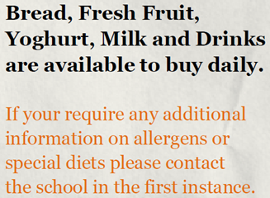
MONDAY IS RED MEAT FREE DAY

