Student Finance – CBS Information for Parents

The online application for student finance is now available and should be completed by 24th April 2020.

Students in receipt of EMA:
Students who have an EMA number must use this number when applying for their student finance. The system will ask for their secret answer and password – they may not have this from before so they will need to ring the Student Loans Company on 0300 100 0077 and they will then issue them with a secret answer and password. They will then be able to continue with their online application.

Completing the Form:
The student needs to create an online account at www.studentfinanceni.co.uk
and complete the application. (N.B. Make sure you log on to the NI student Loan application system.)

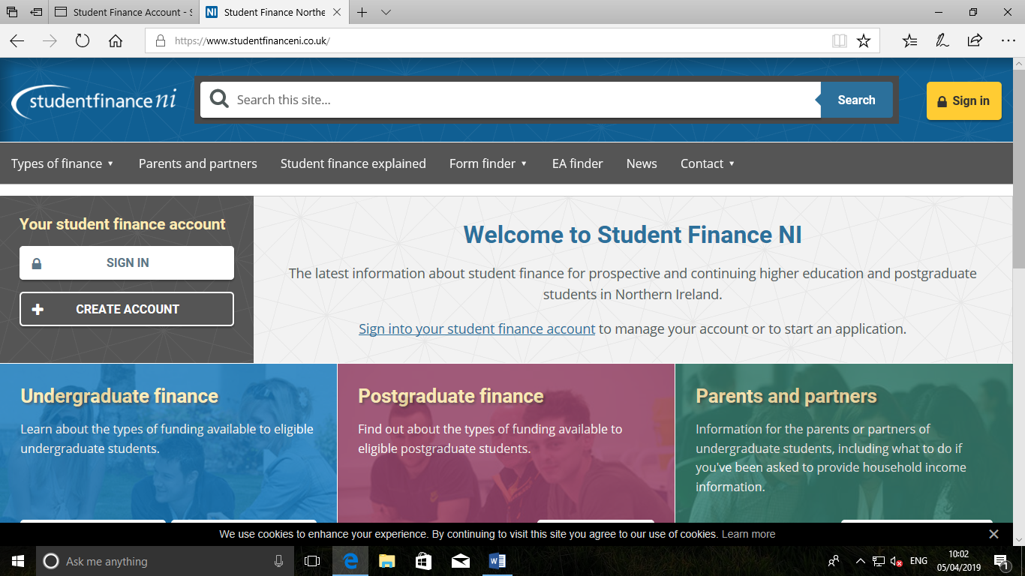

When student’s name is “Mc” or “O” – leave no space between the mc and the rest of the name – e.g. McBride and use O’ with no space either, eg. O’Doherty – if you are on the system previously under the correct version and do it wrong now it will give a new customer reference number.

Parents & students may wish to read the information on undergraduate finance before beginning the application. Students can apply for a tuition fee loan and maintenance fee loan in the same application.

N.B. Students will need their National Insurance Number

What Funding Students can apply for/ could receive:

Tuition Fees - All pupils are entitled to receive a loan for the full amount of tuition fees regardless of family income. N.B. Tuition fees will be paid directly to the university or college.

Maintenance Loan for living expenses: Part of the maintenance loan is means tested (25%) but all students should be entitled to borrow 75% (approx.. £3,600) regardless of family income. Students on family incomes of more than approx. £52,000 will only be able to borrow 75% of the maintenance loan (i.e. the £3,600.)

Household Incomes of over £52,000 – as you will not be eligible for the means tested part of the maintenance loan no parental/ household income details are required on the form – only student details needed. You will not need to complete the means tested section of the application form and students do not need to submit copies of their parents’ income documents.

Grants are available for some students based on income or any additional/ special needs – pupils can ask Student Finance Staff about these.

Pupils with family income of less that £52,000 who are applying for the means tested part of the maintenance loan will need to submit copies of their parents’ income documents (ie.P.60s etc. for the 18/ 19 tax year). Parents should also have entered their income details online or provided the details on a PFF1 form which can be downloaded from the Student FinanceNi website www.studentfinanceni.co.uk

Students are advised to ensure they save / keep a record of their Login details – username & password. ​
Students will be asked to enter the course and university they hope to be studying at in September - do not worry if this needs to be changed in August – simply contact Student Finance and let them know of your new course/ university. ​
Do not worry if it says it doesn't recognise the course ID you have entered – as long as you have the university and course name clearly stated then student finance will be able to locate it.
Paper Applications:
If any pupil is having difficulty with the online process and would prefer to complete a paper form these can be requested from the Student Finance office (028 82 411499) or downloaded from the Student FinanceNi website. Any paper forms can be checked for accuracy on the day that Student Finance staff are at school or alternatively can be posted independently to the Student Finance office in Omagh

