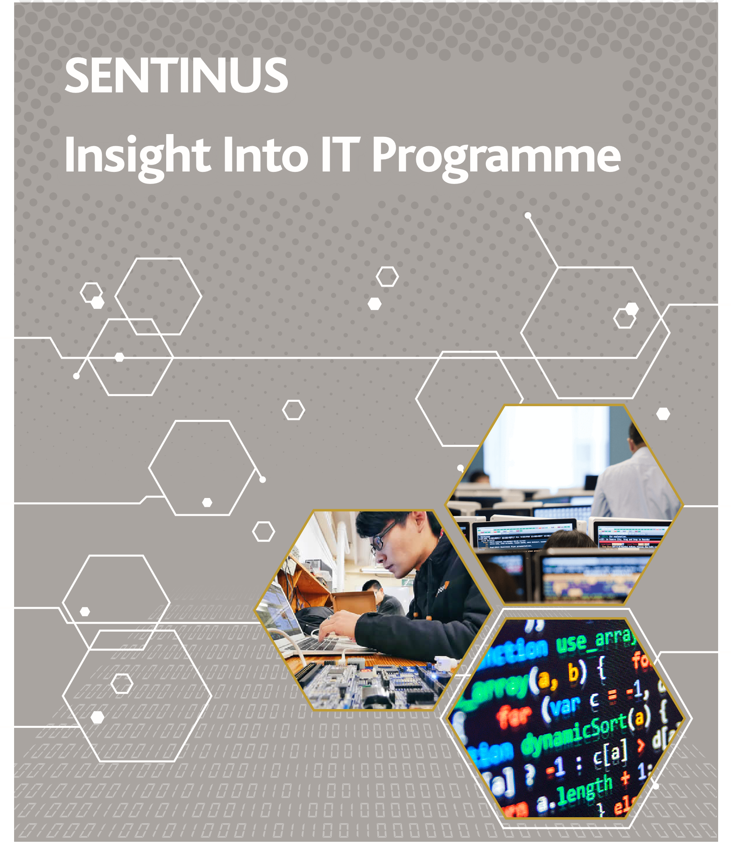
Insight Into IT...

Information Technology (IT)
IT allows business, industry and universities to develop innovative solutions every day to fulfil the world’s business and social needs. IT professionals specialise in using computer and telecommunications technology to store, transmit and translate various types of information including audio, visual, textual and numerical. With the recent explosion in Applications Development, the functionality of mobile phones and computers is improving all the time.
Could you imagine a world without Facebook, Twitter or YouTube? What about doing your online banking or checking the weather on your phone?

Insight Into IT
Over the course of four days, this programme will allow students to explore the various exciting careers that are available within the Information Technology sector. The programme will allow you / your students to make an informed decision on their career path, which is so important in today’s competitive world.
Two of the four days will be spent in
www.sentinus.co.uk
Queens University Belfast and Ulster University Jordanstown, giving the students a taste of what to expect from the various courses available. The other two days will be spent on observational placement in a local IT company in the field of the student’s choice. This will give the students a chance to meet role models and discuss various career options.

Benefits of Participation
By participating in Insight Into IT students will:
Gain first-hand experience in a relevant field.
Find out what you really want to do.
See the facilities that are available at
Queen’s University Belfast and Ulster University, Jordanstown.
Get more information about the Course Entry Requirements.
Two days’ worth of advice from IT professionals.

How to Apply
Applications are open to Lower Sixth students who are currently studying ICT, Software Systems Development, Maths or Physics at A Level. Students must also have an interest in a career in the IT sector.
Places are limited so early application is advisable to avoid disappointment.
Application forms are available from Sentinus. Completed application forms should be returned to Sentinus no later than Thursday 28th February 2019 and the programme will take place from Tuesday 26th March to Friday 29th March 2019.

www.sentinus.co.uk
Lisburn Co.Antrim facebook.com/sentinusNI
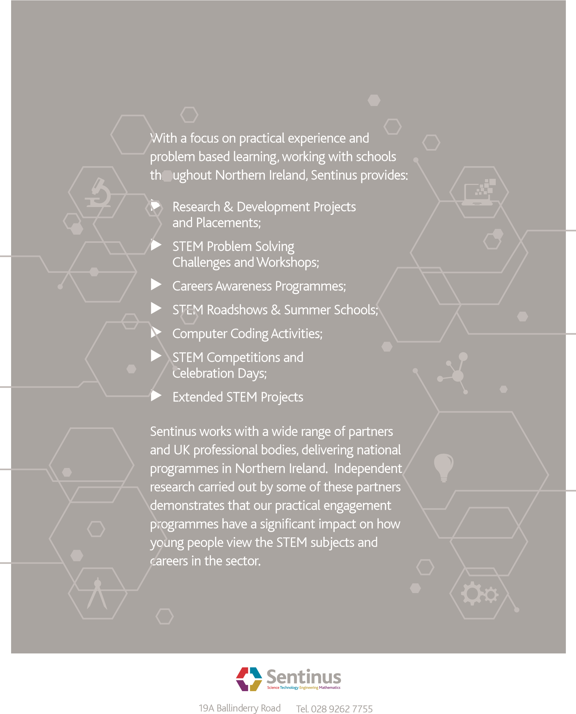
BT28 2SA info@sentinus.co.uk
Northern Ireland www.sentinus.co.uk

