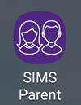**Instructions for setting up SIMS Parent App**

**Before you start..**

It’s a **2 stage process** - you are required to register first and then if you wish to use the SIMS Parent App on your phone, install to your smart phone or device.

(Website access is via <https://www.sims-parent.co.uk>)

Close all other windows during the registration process

**Any usernames/passwords will relate to the account you used to register for the App** (ie; Facebook/Twitter/Google/Microsoft/Apple id)

**Registration Instructions**

Step 1: Open the invitation email that was sent to you from noreply@sims.co.uk to the email address you have provided us. **Check your junk mail if it has not arrived in your Inbox**.

Step 2: Click on the green “Accept Invitation” link within the email

Step 3: Choose account type you would like to register with. (SIMS ID can't be used!). **You will need to have one of the following accounts to be able to register**. (Yahoo, BTinternet etc not acceptable).

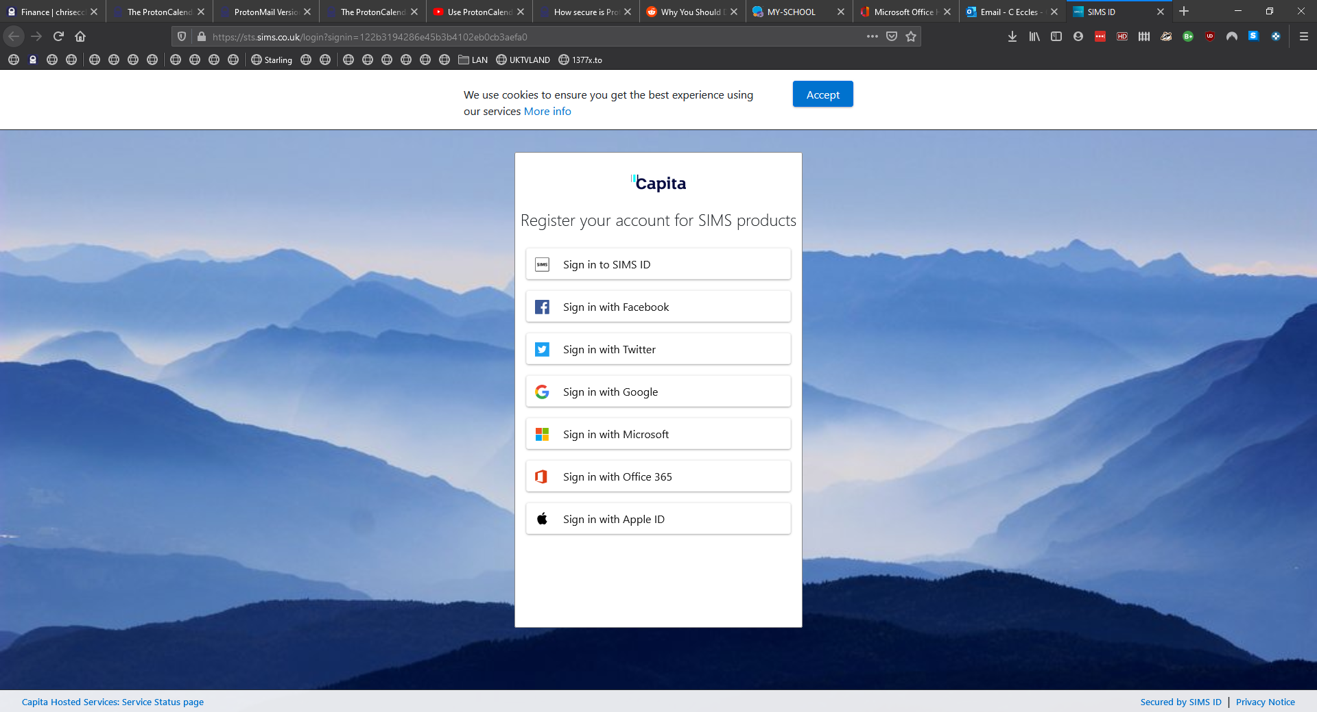

Step 4: Enter email details i.e. email address and password (please note if you are already logged on in the browser to your email, some browsers will pick this up and you won’t have to enter these details)

Step 5: Answer the security question of date of birth for one of your children

(format is dd/mm/yyyy e.g. 26/02/2005)

Step 6: After clicking on the Verify button you may see the “Registration – Account Verification” screen for a few seconds. You will then be registered and are logged in to the web version of App.

**Setting up the SIMS Parent App on your phone**

Step 1: Go to the Google Play store or the Apple store and search for SIMS Parent, install and open.

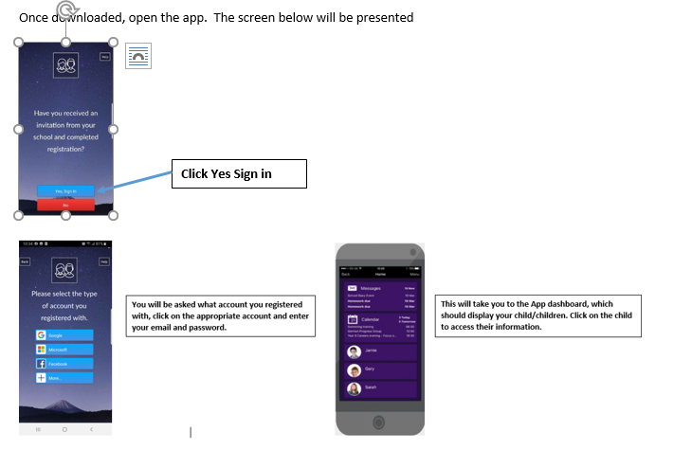

**Troubleshooting**

**1 You must remember the account you registered with**! If you don’t use the app regularly the App will time out requiring your registration details again – i.e. the account you registered with and its password. If this is incorrect, the App will deny access.

2 If you are having difficulty on your phone with the App – can you please try and access it using your browser on pc/laptop via the address [**https://www.sims-parent.co.uk**](https://www.sims-parent.co.uk)

**3 Remember, first question on trying to logon – will always be as below … what account did you use to register? Click on relevant icon to log on .. Apple, Facebook, Twitter, etc**

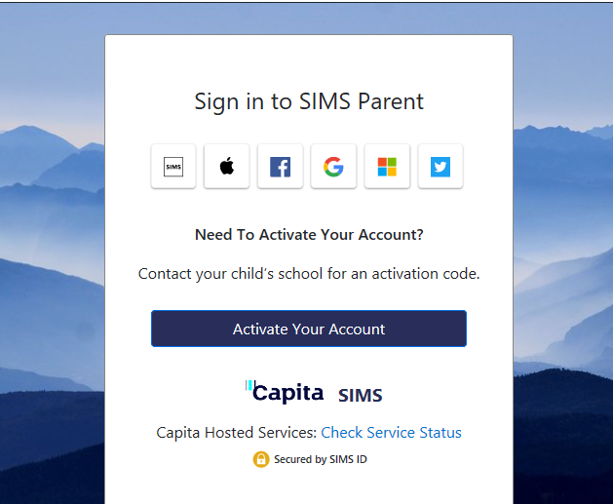 **Click on appropriate icon**