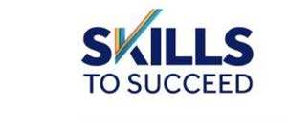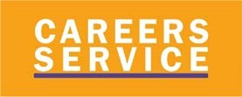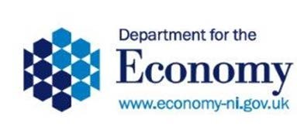

Careers Service
Providing help and support for Students/Parents with Results

Many of you will be receiving results or have children anxiously waiting their results, but are you aware of the help and support that the Careers Service has to offer?

The Careers Service has a team of professionally qualified advisers who can provide free, impartial advice and guidance on a broad range of career options. You can also find a wide range of advice on the nidirect website: https://www.nidirect.gov.uk/campaigns/results

For parents
Information is available for the parents of students and a Guide for Parents has been developed by the Careers Service which aims to help parents to understand the range of options and support available at key transition stages. Areas covered include information on what careers are likely to be in demand in the future and details on the different options after Years 12, 13 and 14.
https://www.nidirect.gov.uk/sites/default/files/publications/careers-service-a-parental-guidePDF-June-2020.pdf

Contact a careers adviser
Professionally-qualified careers advisers are still contactable and can give you impartial information, advice and guidance on the options available to you. To contact a careers adviser, you can:
- go online and chat with an adviser at https://www.nidirect.gov.uk/services/chat-with-acareers-adviser
- telephone: 0300 200 7820
- email Careers Service by completing the online form at Ask Careers https://selfservice.nidirect.gov.uk/TellUs/Careers_Service/Ask_careers/
For A levels: Careers advisers will be available from 9.30 am to 7.00 pm to provide support to A Level students on Thursday 13 and Friday 14 August.
For GCSEs: Careers advisers will be available from 9.30 am to 7.00 pm to provide support to GCSE students on Thursday 20 and Friday 21 August.

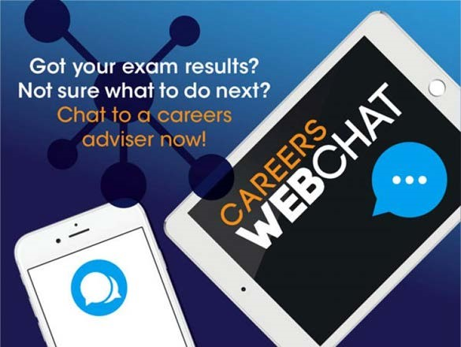

Results guidance
The Careers Service also has lots of useful information available on the NI Direct results page https://www.nidirect.gov.uk/campaigns/results including articles on:
- staying on at school
- going to college
- apprenticeships/ training options
- university and higher education
- careers advice
- student finance
- student accommodation
- gap year
- finding a job

A Level Students - Contacting universities and colleges
You also can find contact details for universities and colleges in Northern Ireland below:
- Universities and Colleges Admissions Service (UCAS) https://www.ucas.com/
- Queen's University Belfast https://www.qub.ac.uk/
- Ulster University https://www.ulster.ac.uk/
- Stranmillis University College https://www.stran.ac.uk/
- St Mary's University College https://www.stmarys-belfast.ac.uk/
- Open University http://www.open.ac.uk/
- College of Agriculture, Food and Rural Enterprise (CAFRE) https://www.cafre.ac.uk/

Querying your results
This year if you have a query on any issue relating to your results your school/college will be able to advise you of the procedure to follow or contact CCEA by emailing helpline@ccea.org.uk

Online help
To help you explore options available, there is lots of useful information available on nidirect for you and your dependents on what you can do. You can find information about:
- options after Year 12
- options after year 14
- after your A level results
You can find information on the many options available in the following section:
https://www.nidirect.gov.uk/campaigns/results

More useful links
- Education Maintenance Allowance
- Skills to Succeed
- Options after year 14
- Student life
- Student finance
- Careers

