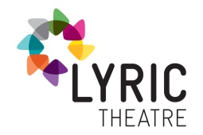  

**PRODUCTION & TECH COURSE 2022**

I first worked with the Lyric

Thank you for your interest in applying for this new course at the Lyric Theatre, Belfast!

The closing date is **Friday 17th** **December** **2021.** We will then meet with applicants during the week beginning **3rd January 2022** – an informal chat so you can find out more about what’s involved and we can learn a little bit more about you.

The course will begin on **Saturday 22nd January** **2022** and will run on Saturdays from 10am until 5pm until **Saturday 12th March**.

Sessions will usually be from 10:00-13:00 and 14:00-17:00.

In addition to the 9 group sessions, each participant will be offered 2 three hour placement opportunities in their particular area(s) of interest.

Some further information for you:

* The cost of running the course is heavily subsidised by the Garfield Weston Foundation
* There is a non-refundable fee of £80 for those who accept a place
* Some bursary places will be available
* Places are limited, so you should be free to attend every session to make the most of the opportunity

When you’ve completed this form, please email it to [philipcrawford@lyrictheatre.co.uk](mailto:philipcrawford@lyrictheatre.co.uk)

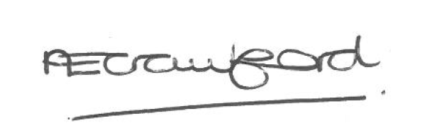

Philip Crawford Head of Creative Learning

  

PLEASE INSERT A PASSPORT STYLE PHOTOGRAPH HERE OR ATTACH IT TO YOUR EMAIL APPLICATION

**PRODUCTION & TECH COURSE APPLICATION FORM**

Name: …………………………………………………………………………………………

Address: …………………………………………………………………………………………  
Postcode: …………………………………………………………………………………………

Telephone: ………………………………………….……………………………………………..

Email: …………………………………………………………………………………………

Age: ……………………………………… (whenever you complete this form)

**EDUCATION**

|  |  |  |  |
| --- | --- | --- | --- |
| **AFTER GCSE** | | | |
| Year (From/To) | Level (eg A Levels/diploma) | Subjects | Grade Obtained |
|  |  |  |  |
| **UNIVERSITY/COLLEGE ATTENDED: ……………………………………………………………………………………** | | | |
| Year (From/To) | Level (eg A Levels/degree/diplomas) | Course | Grade Obtained |
|  |  |  |  |

**ANY RELEVANT EXPERIENCE IN THEATRE:** (Please note that previous experience is not a requirement)  
…………………………………………………………………………………………………………………………………………………………….………………….…………………………………………………………………………………………………………………………………………………………………………………………………………………………………………………………………………………………………………………………………………………………………..

**WHAT DO YOU HOPE TO GAIN FROM THE COURSE?**

…………………………………………………………………………………………………………………………………………………………….………………….……………………………………………………………………………………………………………………………………………………………………………………………………………………………………………………………………………………………………………………………………………………………………

**WHAT QUALITIES DO YOU THINK YOU WOULD BRING TO THE COURSE?**

…………………………………………………………………………………………………………………………………………………………….………………….…………………………………………………………………………………………………………………………………………………………………………………………………………………………………………………………………………………………………………………………………………………………………..

**ARE YOU INTERESTED IN A PARTICULAR AREA OF THEATRE?** (eg lighting, sound, stage management)

…………………………………………………………………………………………………………………………………………………………….………………….

…………………………………………………………………………………………………………………………………………………………….………………….

Please give details of someone you have worked with recently (ideally within a theatre / drama / performance project)who would provide a **reference** for you,

Name: ……………………………………………………………………… Tel: …………………………………………………………..  
Position: …………………………………………………………………………………………………………………………………….…….……

**I have read the notes above and would like to apply for the Lyric Drama Studio course.**

Signed: …………………………………………………..……………… Date: ………………………………………….……………….

The closing date is **Friday 17th** **December** **2021**